Week 3: Data Visualization and Insights Communication

Data Visualization and Insights Communication
In this week, I developed the Heart Disease Analytics Dashboard.

1. Key KPIs Created
- Total Patients: 1025
- Heart Disease Patients: 526
- Healthy Patients: 499
- Heart Disease %: 51%
- Average Age: 54.43

2. Visualizations Developed
📊 Age Group vs Heart Disease
- Highest cases observed in 51–60 and 61–70 age groups.
- Younger age groups show significantly fewer cases.

👨 Gender Distribution
- Majority of heart disease patients are male (approx. 57%).
- Female patients account for around 43%.

📈 Cholesterol vs Maximum Heart Rate (thalach)
- Patients with heart disease show different heart rate patterns.
- Higher cholesterol combined with lower maximum heart rate indicates higher risk.

3. Dashboard Design Principles
- Clear KPIs at top
- Interactive filters
- Age and sex-based segmentation
- Easy-to-read color contrast
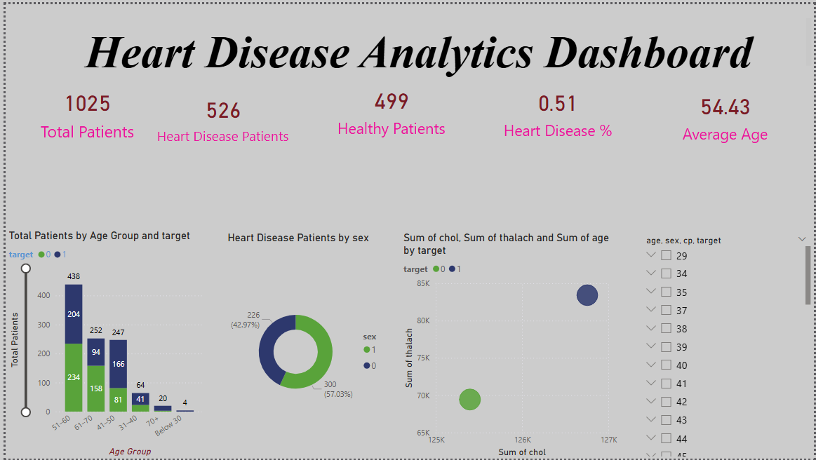
The dashboard was designed to help non-technical stakeholders quickly understand risk distribution.

